|  |
| --- |
|  |
| 8 Gardenfield, Skellingthorpe, Lincoln LN6 5SP  Telephone: 07813 900081  Email: paulamellows@hotmail.com |

9th May 2024

Glentworth Parish Council

Glentworth Village Hall

Stoney Lane

Glentworth

Gainsborough DN21 5DF

Dear Sirs,

**Independent Examination Report on Annual Accounts for the Year ending 31st March 2024**

From the records provide I can confirm that the Council’s Financial Records have been contemporaneously recorded, including a PAYE payroll system, and the results and balances provided by the Clerk to the Council on a monthly basis.

It is also apparent risk assessments have been reviewed on a regular basis.

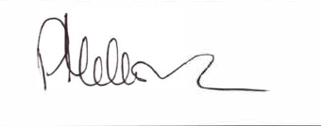Yours faithfully

Paula Mellows FMAAT